**How to add default route** :

endpoints.MapControllerRoute(

"default Route",

"{controller=Home}/{action=Index}/{id?}")

/**************************************/

**How to deals with controllers** :

services.AddControllersWithViews();

/**************************************/

**how to register services in wwwroot** :

app.UseStaticFiles();

/**************************************/

**how to make visual studio run changes in views with out re run program**

1-Add this package :  [Microsoft.AspNetCore.Mvc.Razor.RuntimeCompilation](https://www.nuget.org/packages/Microsoft.AspNetCore.Mvc.Razor.RuntimeCompilation/)

2-Add this services : services.AddControllersWithViews().AddRazorRuntimeCompilation();

/**************************************/

**DbContect Steps :**

Add Packages due to deal with DbContext :

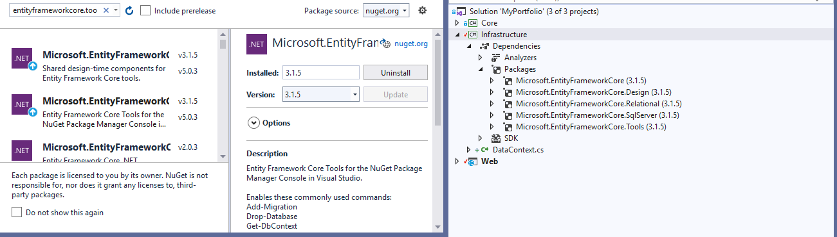

Add dotnet ef command :

dotnet tool install --global dotnet-ef

dotnet add package Microsoft.EntityFrameworkCore --version 6.0.0-preview.1.21102.2

dotnet add package Microsoft.EntityFrameworkCore.Design --version 6.0.0-preview.1.21102.2

dotnet add package Microsoft.EntityFrameworkCore.SqlServer --version 6.0.0-preview.1.21102.2

dotnet add package Microsoft.EntityFrameworkCore.Relational --version 6.0.0-preview.1.21102.2

dotnet add package Microsoft.EntityFrameworkCore.Tools --version 6.0.0-preview.1.21102.2

Command to create Migation :

dotnet ef migrations add InitialCreate -s ..\Web\Web.csproj

Command to update database :

dotnet ef database update -s ..\Web\Web.csproj